Budsville GameFi Plant Sim
Budsville Weed simulation built with ERC-721 Plant NFTs, ERC-6551 token-bound accounts (smart wallets), and an ERC-1155 item economy for all consumables, upgrades, and harvest outputs. Each Plant NFT owns its own smart wallet that holds the items it needs to survive, grow, and produce results over a 12-week lifecycle.
Plants progress through growth stages (seed → sprout → vegetation → bloom → harvest window) based on time + care metrics (water/food/health/quality), with failure states like wilted or dead if neglected. The base 12-week cycle can be shortened and outcomes improved using ERC-1155 upgrades held by the plant’s wallet, enabling players to reduce total grow time and increase final yield/quality.
At the end of the cycle, plants produce either a bud harvest or a seed harvest depending on whether the user pollinated the plant. Pollinated plants generate seeds whose genetics are inherited from both parents using a deterministic mixing model (with optional randomness), creating lineage-driven trait variation across generations. Plant metadata updates dynamically to reflect current stage, care status, upgrades applied, pollination state, and genetics, supporting rich rendering (e.g., a closet-scene animation_url).
Harvest outcomes feed into a Harvest Pool, where rewards are distributed pro-rata by plant “points” earned from successful growth, quality, genetics, and boosts—allowing scalable redemption without looping over all plants. The entire design is multicall-friendly, with view functions exposing all state required for the dApp to batch-read plant status, progress, genetics, and pending rewards efficiently.

Concept
Each Plant NFT (ERC-721) owns its own ERC-6551 Token Bound Account (TBA) (“plant wallet”).
That plant wallet holds:
- Consumables (ERC-1155): water/food/nutrients/etc (game items)
- Upgrades (ERC-1155): reduce time, increase yield, quality boosts
- State-relevant loot: harvested items, seed items, trophies, etc
The plant is a living simulation with a 12-week cycle, where:
- Care determines survival + quality
- Upgrades reduce total grow time or increase outcomes
- After the grow cycle, you either:
  - Harvest buds, or
  - Harvest seeds if pollinated
- Harvest outcome feeds a reward pool and grants the user a share based on successful plants and their “points”.

1) Tokens & Contracts

A) PlantNFT (ERC-721)
- Mint seeds/plants
- Reads its ERC-6551 account from theregistry/account manager
- tokenURI() reflects current stage/health/genetics/outcomes (via renderer or on-chain JSON)

B) PlantCore (simulation + rules engine)
Single source of truth for:
- lifecycle timing (12 weeks base)
- stage computation
- care metrics, health, quality
- pollination status
- harvest logic (buds vs seeds)
- point assignment for rewards
- tracking upgrades consumed/installed

C) Items1155 (ERC-1155)
Holds all in-game items:
- CARE items: Water, Food, Nutrients, etc
- UPGRADES: Time reducers, Yield boosters, Quality boosters, Genetics modifiers, etc
- OUTPUTS: Bud item(s), Seed item(s), maybe “Trim”, “Essence”, etc

D) HarvestPool
Takes “harvest returns” and distributes rewards pro-rata by plant points (no loops).

E) GeneticsLib
Encodes traits and produces child genetics from two parents.
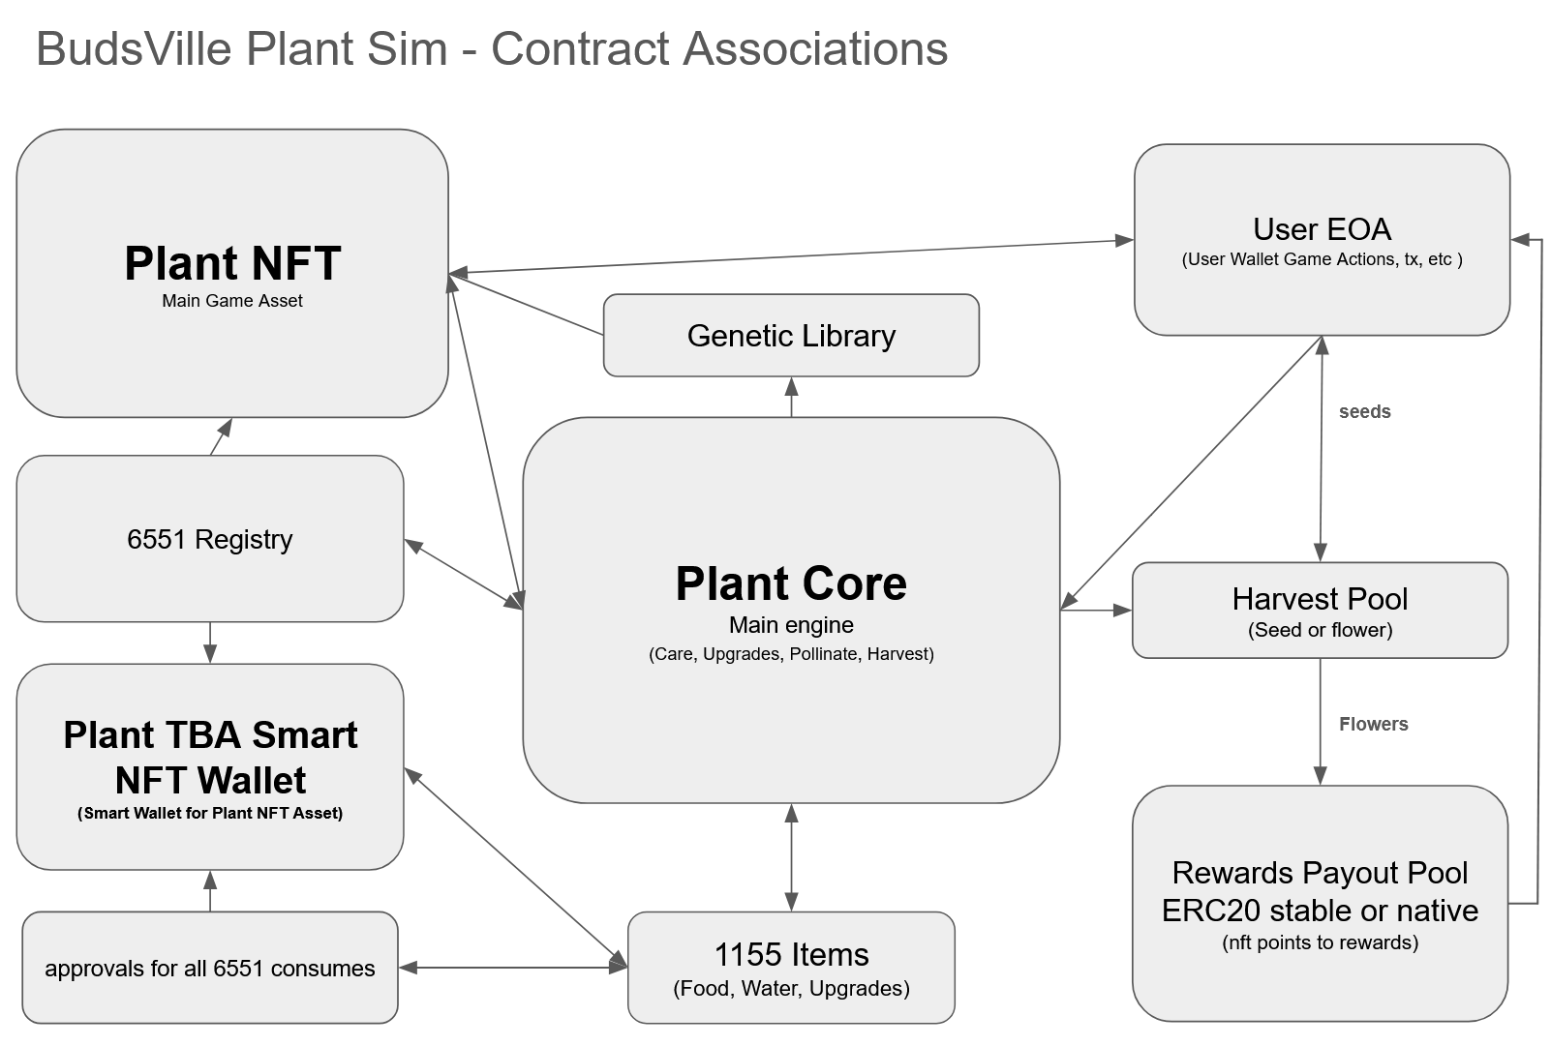

2) The 12-Week Grow/Breeding Cycle

Timing
- Base duration: 12 weeks (the full lifecycle)
- The lifecycle can be reduced by applying upgrade items (ERC-1155) held by the plant’s TBA.
Important: you do not need to update every week on-chain. You compute stage from timestamps + modifiers.

Stage progression (example mapping)
You can map the 12 weeks into stages like:
- SEED → SPROUT → VEGETATION → BLOOM → HARVEST_WINDOW → POST_HARVEST
- Failure paths:
  - WILTED (bad care / too long neglected)
  - DEAD (terminal)
Stage is derived from:
- elapsed = now - plantedAt
- effectiveTotalDuration = 12 weeks - timeReductionFromUpgrades
- progress = elapsed / effectiveTotalDuration (clamped 0..1)
- plus health gating (if health drops too low you can force wilt/dead regardless of time)

3) ERC-6551 Smart Wallet Inventory Model (the key point)
Each plant’s TBA holds its ERC-1155 inventory.

How “care” spends items
User calls PlantCore.care(tokenId, actions...).
PlantCore:
- verifies caller is NFT owner/approved
- resolves the plant’s TBA address from the registry/account manager
- consumes required items from the TBA:
  - simplest: Items1155.safeTransferFrom(tba, burnSinkOrCore, id, amount, "")
To make this smooth:
- the TBA grants operator approval to PlantCore (one-time), then all care is 1-tx.

4) Care, Metrics, and “Quality”
Store minimal state and compute decay on the fly:
Per plant:
- plantedAt
- lastCareAt
- water (0..100)
- food (0..100)
- health (0..100)
- quality (0..10_000 or 0..100)
- genes (uint256 packed)
- pollinatedWith + pollinatedAt
- harvested / wilted / dead
- timeReductionApplied (seconds)
- yieldBoostApplied (bps)
- qualityBoostApplied (bps)
- pointsEarned (set on harvest)
Decay model (game):
- water/food decay over time since lastCareAt
- if levels go too low too long → health declines
- good care increases quality gradually (bounded)
- upgrades affect the rate or the caps
This produces a clear “skill loop” without requiring frequent transactions.

5) Upgrades (ERC-1155) — Reduce time / Increase yield
Upgrades are just ERC-1155 items the TBA holds, and you “apply” them:

Types of upgrades
- Time Reduction: reduces total lifecycle duration (e.g. -1 week per item, capped)
- Yield Boost: increases final buds/seeds (e.g. +5% per item, capped)
- Quality Boost: increases final points multiplier
- Optional: “stability” upgrades that reduce decay or prevent wilt threshold triggers
Implementation:
- applyUpgrade(tokenId, upgradeId, qty):
  - consumes upgrade items from TBA
  - updates modifiers in plant state
  - enforces caps (so whales can’t go infinite)
This creates a very clean monetization path without touching ERC-20.

6) Pollination & Seed Harvest vs Bud Harvest

Pollination
Only allowed during BLOOM (or late bloom):
- pollinate(plantA, plantB) sets:
  - plantA.pollinatedWith = plantB
  - plantA.pollinatedAt = now
- you can allow either:
  - symmetric pollination (both get pollinated)
  - or directional (one is “mother”)

Harvest decision
At harvest:
- If not pollinated → Bud harvest
- If pollinated → Seed harvest (and optionally reduced buds)
Outputs are minted/transferred to the plant TBA or to the owner (to decide atm).
I recommend: output goes to TBA for consistency.

7) Genetics Inheritance (seed production)
Each plant has genes (packed uint).
When seeds are produced:
- childGenes = GeneticsLib.mix(genesA, genesB, randomness)
- seed count depends on:
  - mother quality
  - yield boosts
  - genetic fertility trait(s)
Metadata must include genetics, so seed NFTs can show:
- parent traits
- generation
- rarity bands
Randomness options:
- VRF (best)
- commit/reveal (good)
- pseudo-random (ok for low-stakes): keccak256(block.prevrandao, tokenId, pollinatedAt, ...)

8) Harvest Pool Rewards (percentage based on plants grown)
Harvest is returned to the pool and redeemed percentage based on qty grown
Use “points” to represent “qty grown + quality” fairly:
At harvest:
- compute points from:
  - reached harvest successfully (base points)
  - quality multiplier
  - genetics multiplier
  - yield boost multiplier
  - optional: stage speed bonus (finishing early)
Then the pool distributes rewards pro-rata by points:
- deposit rewards into pool
- claim rewards per plant or per owner
This scales and avoids loops.
You can choose whether claims go to:
- the NFT owner, or
- the plant TBA (then owner can withdraw)

9) Metadata & Rendering
tokenURI() should reflect:
- current stage
- alive/wilted/dead
- water/food/health/quality
- pollination state
- genetics summary (or hash + visible trait tiers)
- estimated harvest type (buds vs seeds)
- modifiers applied (time reduction / boosts)
- if harvested: final outputs + points
Rendering:
- animation_url can be a “closet scene” that changes visuals based on stage + health + traits.

10) Multicall3-friendly reads (for the app)
Expose view methods that return packed structs:
- getPlant(tokenId) → full state needed for UI
- computeStage(tokenId) → stage enum + progress bps
- getModifiers(tokenId) → timeReduction/yieldBoost/qualityBoost
- getPollination(tokenId)
- pendingRewards(tokenId) via HarvestPool
This makes the front-end able to batch everything in one multicall.

